



Name : Hafsa Shahid
Reg no : B25F34CYS101
Program : Cybersecurity
Instructor’s name: Hassan Ali
Date Submitted : 10 / 07 / 26
Deadline : 10 / 07 / 26
Assignment Report # 5

\

• INTRODUCTION •
In this task we learned about a powerful open-source network scanning tool Nmap. The main objective was to run a few commands on the terminal. We were given an assignment at the end; it goes as follows.

Assignments Tasks:

Task : Run Commands, Scan localhost, Scan another authorized machine. Identify open ports. Identify running services. Identify operating system.

• TASK •
Task : Run Commands, Scan localhost, Scan another authorized machine. Identify open ports. Identify running services. Identify operating system.

Steps Followed:
- Run command for Scan localhost.
- Run command for Scan another authorized machine.
- Run command for Identify open ports.
- Run command for Identify running services.
- Run command for Identify operating system.

• STEP # 01 •
Step # 01 : Run command for Scan localhost.
- Open terminal.
- Type the command nmap localhost.
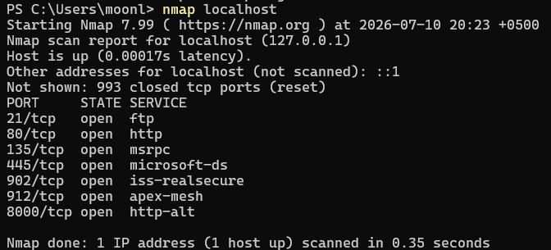
- Output is as follows.

Step #01: Command nmap localhost

• STEP # 02 •
Step # 02 : Run command for Scan another authorized machine.
- Open terminal.
- Type the command nmap -sV 192.168.1.155.
- Output is as follows.

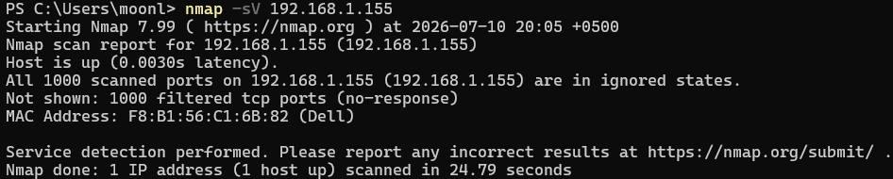

Step #02: Command nmap -sV 192.168.1.155

• STEP # 03 •
Step # 03 : Run command for Identify open ports.
- Open terminal.
- Type the command nmap -F localhost.
- Output is as follows.
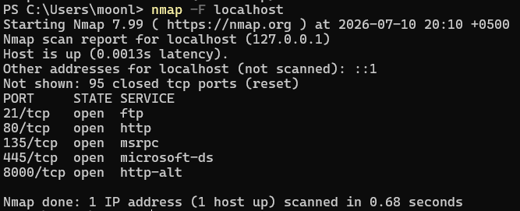

Step #03: Command nmap -F localhost

• STEP # 04 •
Step # 04 : Run command for Identify running services.
- Open terminal.
- Type the command nmap -sV localhost.
- Output is as follows.

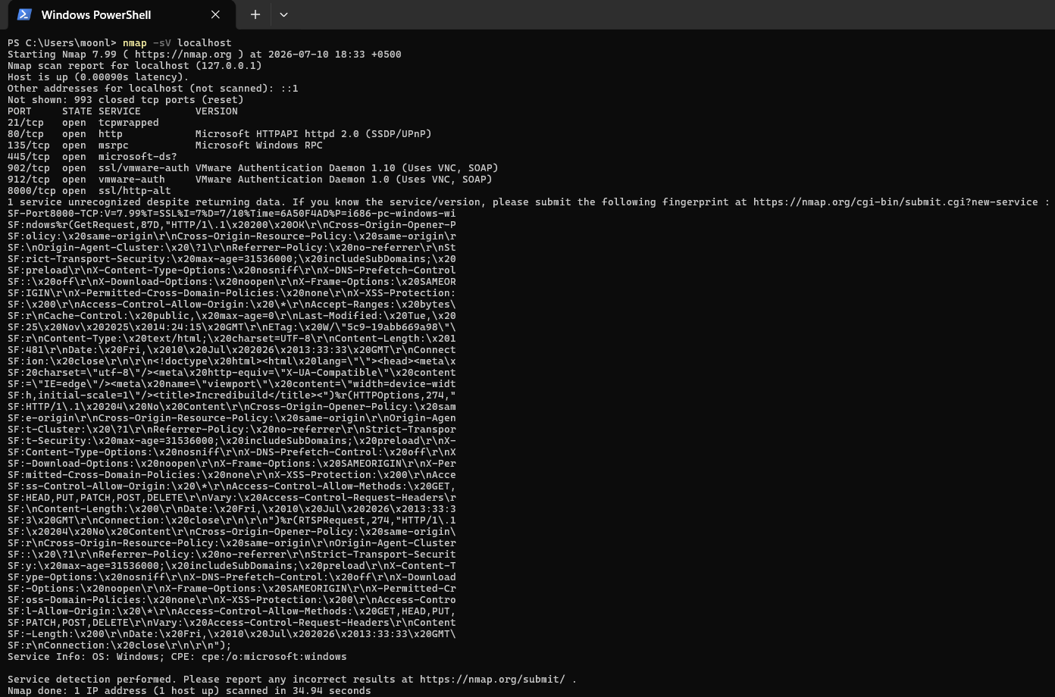

Step #03: Command nmap -sV localhost.

• STEP # 05 •
Step # 05 : Run command for Identify operating system.
- Open terminal.
- Type the command nmap -O localhost.
- Output is as follows.
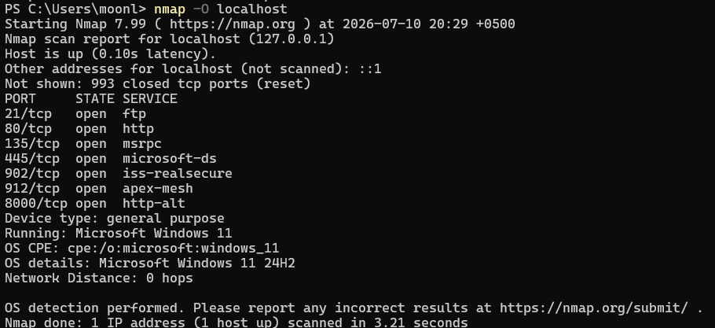

Step #03: Command nmap -O localhost.
Assignment Conclusion:
In this assignment we ran some commands in the terminal using nmap to get a understanding of networking fundamentals. This increased and polished my ability to use and learn more about cybersecurity.

• The End •

